DATA WAREHOUSE

A Project Report Submitted
For

Information Technology (402)
By

KRISHNA SUNARIYA
Under the guidance of
Mr. Praveen Kumar Joshi


EVER GREEN SENIOR SECONDARY SCHOOL
(GOVERNED BY EDUCATIONAL WELFARE SOCIETY)
TULARAMPUR – 263139, DISTR
CERTIFICATE

This is to certify that the project entitled “DATA WAREHOUSE” being submitted to Evergeen Senior Secondary School, Haldwani for the project work of INFORMATION TECHNOLOGY is a record of the work carried by MR. PRAVEEN KUMAR JOSHI under my guidance and supervision.

Date:8/11/2021 Supervisor
MR. PRAVEENJOSHI
TGT Computer
Ever Green Sr. Sec. School, Haldwani
Forwarded By:

DATA Warehouseing.
Data warehousing is the secure electronic storage of information by a business or other organization. The goal of data warehousing is to create a trove of historical data that can be retrieved and analyzed to provide useful insight into the organization’s operations.


What is data warehouse with example?
Also known as enterprise data warehousing, data warehousing is an electronic method of organizing, analyzing, and reporting information. ... For example, data warehousing makes data mining possible, which assists businesses in looking for data patterns that can lead to higher sales and profits.
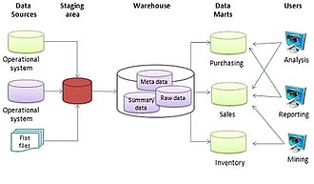
What is data warehousing used for?
Data warehouses are relational environments that are used for data analysis, particularly of historical data. Organizations use data warehouses to discover patterns and relationships in their data that develop over time.
What are the 3 characteristics of data warehouse?
There are three prominent data warehouse characteristics:
- Integrated: The way data is extracted and transformed is uniform, regardless of the original source.
- Time-variant: Data is organized via time-periods (weekly, monthly, annually, etc.).
- Non-volatile: A data warehouse is not updated in real-time.

What are the difference between various types of data warehousing?

KEY LEARNING. Data Warehouse (DWH), is also known as an Enterprise Data Warehouse (EDW). A Data Warehouse is defined as a central repository where information is coming from one or more data sources. Three main types of Data warehouses are Enterprise Data Warehouse (EDW), Operational Data Store, and Data Mart.
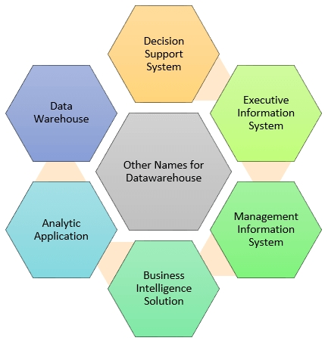
What are the stages of data warehouse?

4 Stages of Data Warehouses:-
Stage 1: Offline Database. In their most early stages, many companies have Data Bases. …
Stage 2: Offline Data Warehouse. …
Stage 3: Real-time Data Warehouse. …
Stage 4: Integrated Data Warehouse.

What do you mean by data warehousing?
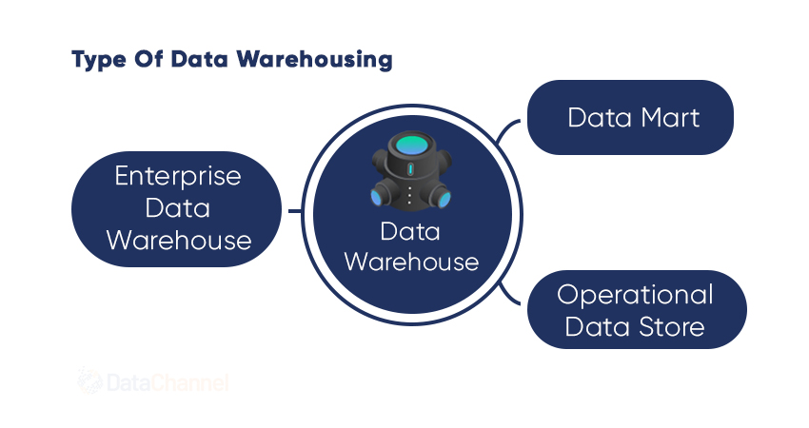
Data warehousing is the secure electronic storage of information by a business or other organization. … The warehouse becomes a library of historical data that can be retrieved and analyzed in order to inform decision-making in the business.
Data warehousing is a vital component of business intelligence. That wider term encompasses the information infrastructure that modern businesses use to track their past successes and failures and inform their decisions for the future.
- Data warehousing is the storage of information over time by a business or other organization.
- New data is periodically added by people in various key departments such as marketing and sales.
- The warehouse becomes a library of historical data that can be retrieved and analyzed in order to inform decision-making in the business.
- The key factors in building an effective data warehouse include defining the information that is critical to the organization and identifying the sources of the information.
- A database is designed to supply real-time information. A data warehouse is designed as an archive of historical information.
How Data Warehousing Works
The need to warehouse data evolved as businesses began relying on computer systems to create, file, and retrieve important business documents. The concept of data warehousing was introduced in 1988 by IBM researchers Barry Devlin and Paul Murphy.1

Data warehousing is designed to enable the analysis of historical data. Comparing data consolidated from multiple heterogeneous sources can provide insight into the performance of a company. A data warehouse is designed to allow its users to run queries and analyses on historical data derived from transactional sources.

Does data warehousing have a future?


The data warehousing market is growing constantly as it is increasingly being used by the BFSI sector. It is the building block for most data-centric innovations and is likely to continue growing in the coming years.
Why is data warehousing important?
Data warehousing improves the speed and efficiency of accessing different data sets and makes it easier for corporate decision-makers to derive insights that will guide the business and marketing strategies that set them apart from their competitors.

Is the data in a data warehouse generally updated in real time?
Active Data Warehousing is the technical ability to capture transactions when they change, and integrate them into the warehouse, along with maintaining batch or scheduled cycle refreshes. … A real-time data warehouse has low latency data and provides current (or real-time) data.

Active Data Warehousing is the technical ability to capture transactions when they change, and integrate them into the warehouse, along with maintaining batch or scheduled cycle refreshes. An active data warehouse offers the possibility of automating routine tasks and decisions. The active data warehouse exports decisions automatically to the On-Line Transaction Processing (OLTP) systems.

Real-time Data Warehousing describes a system that reflects the state of the warehouse in real time. If a query is run against the real-time data warehouse to understand a particular facet about the business or entity described by the warehouse, the answer reflects the state of that entity at the time the query was run. Most data warehouses have data that are highly latent – or reflects the business at a point in the past. A real-time data warehouse has low latency data and provides current (or real-time) data.
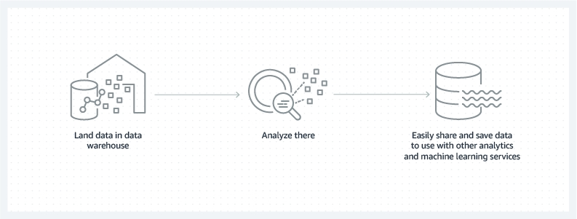

What are the benefits of using a data warehouse?
Benefits of a data warehouse include the following:

- Informed decision making
- Consolidated data from many sources
- Historical data analysis
- Data quality, consistency, and accuracy
Separation of analytics processing from transactional databases, which improves performance of both systems

Is data warehouse a good career?
While skills like Data Analysis and SQL are steadily increasing, it is Big Data & Analytics skills that are the best paid in India, with a median salary of Rs. 939,275. An interesting trend to note is that with every additional year of experience, Data Warehousing and Business Intelligence Professionals earn multifold.
Now Let's Look At Some Business Benefits Of DWaaS
- #1. Data Accessibility To Business Users. ...
- #2. Enhanced Performance And Speed. ...
- #3. High Data Storage Capacity. ...
- #4. Quick Disaster Recovery. ...
- #5. Shared Cost Of Ownership. ...
- Investment and Insurance sector. ...
- Retail chains. ...
- Healthcare.
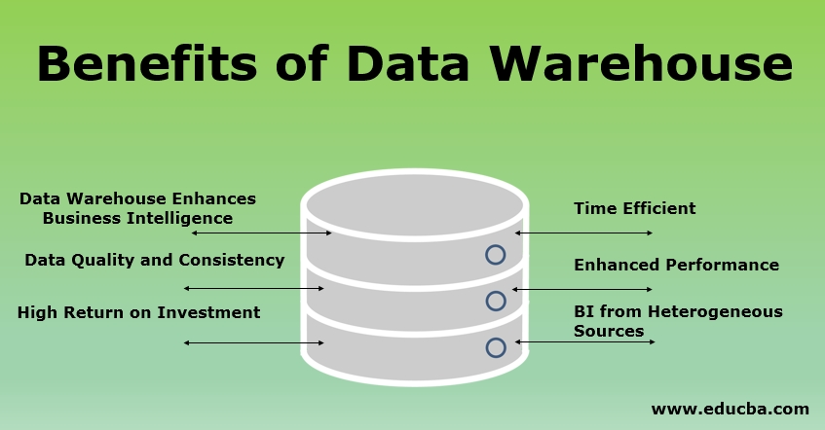

What is the benefit of modern data warehouse?
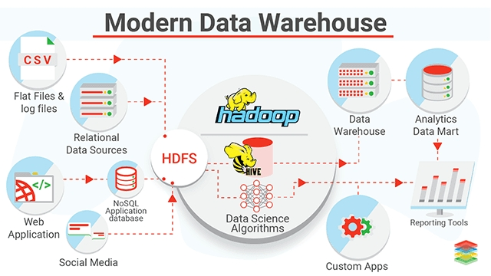
Rapid integration of data into the environment. Improved efficiency in integration reducing time, cost and efforts.+ Opportunity to enable innovative new data models

What are the 3 characteristics of data warehouse?
- There are three prominent data warehouse characteristics:
- Integrated: The way data is extracted and transformed is uniform, regardless of the original source.
- Time-variant: Data is organized via time-periods (weekly, monthly, annually, etc.).
- Non-volatile: A data warehouse is not updated in real-time.

Data Warehouse Benefits For Organizations
Now that we are aware of how a data warehouse works, it is time to know the benefits of a data warehouse and how exactly it can help your business grow and scale. Whether you own a digital marketing agency or have a traditional brick and mortar setup, data warehousing can yield several benefits for your business.
Below are 7 key benefits of data warehousing for your business:

1. Data Warehousing Saves Time
In the modern fast-paced world of cut-throat competition, your capacity as a business to swiftly make refined decisions is essential to outpace your opponents.
A data warehouse provides you access to all your required data in a matter of minutes. So, you and your employees don’t have to dread an approaching deadline. All you need to do is use your data warehouse to acquire data within seconds. And most data warehouse building solutions allow you to do that without using a complex query or machine learning.
With data warehousing, your business won’t have to rely on the 24/7 availability of a technical expert to troubleshoot problems associated with retrieving information. This way, you can save plenty of time.

2. Data Warehousing Improves Data Quality
The refined quality of data helps guarantee that your company’s policies are based on precise information about your corporate exertions.
With data warehousing, you can transform data from multiple sources into a shared arrangement. This way you can ensure the reliability and quality of your corporate data. This way, you can identify and remove replica data, inadequately recorded data, and misinformation.
Implementing a data quality management program can be both costly and exceptionally laborious for your company. You can easily use a data warehouse to eliminate a number of these annoyances while saving money which will eventually justify your decision to invest in a data warehousing system.
After all, poor data quality is a burden for your business and can decline the overall efficiency of your plans.

3. Data Warehousing Improves Business Intelligence
You can use a data warehouse to gather, assimilate, and derive data from any source all through your business undertakings. As a result, your BI will improve by leaps and bounds, owing to the capability of effortlessly consolidating data from distinct sources.
Let’s face it: cross-referencing numerous databanks can be tough, and at times, unmanageable. But, with a data warehouse in place, everyone on your team can have an integrated understanding of all the relevant information in a timely manner.
A data warehouse allows your sales and marketing teams to track and identify which of your targets are dynamic and have accounts on social networking websites. So, if you’re running a promotion that targets females in their mid-twenties working in the beauty industry, your team can fetch profiles of your target audience using your data warehouse within seconds. They won’t even have to cross-reference worksheets and databanks.
4. Data Warehousing Leads to Data Standardization and Consistency
Another important benefit of using a data warehouse is the standardization of big data. Your business can benefit from a data storage or data mart in a similar arrangement. As data warehousing stores data from diverse sources, such as a transactional system, in a consistent fashion, each source will generate outcomes that are synchronized with other sources. This guarantees improved quality and homogeneity of data. Consequently, you and your team can feel assured that your data is correct, which will result in more cognizant corporate decisions.

5. Data Warehousing Enhances Return on Investment (ROI)
According to a report by the International Data Corporation (IDC), using a data warehouse generates an average 5-year ROI of 112 percent with an average payback period of 1.6 years.

A data warehouse empowers you to increase your overall ROI by harnessing the value and acumen implanted within numerous databanks. As you increasingly make use of the information consolidated and systematized within the data warehouse, you achieve more out of your investment.

Thus, a data warehouse allows you to elucidate, enumerate, and validate the efficiency of your initiatives to higher management in terms of improved ROI.

6. Data Warehousing for Historical Data
As a data warehouse allows you to store large volumes of historical data from operational systems, you can easily investigate different time phases and inclinations that can be ground-breaking for your company. With the right and real-time data in your hands, you can make superior corporate decisions concerning your business strategies.
Predicting the results of your business processes is a significant aspect of being a resourceful business person. It can be challenging to forecast the future without a tangible understanding of your historical achievements and letdowns.
For example, suppose you own a fashion brand and you plan to launch a promotional campaign for your new clothing line. With the help of your data warehouse, you can access and analyze historical data from your previous campaigns in order to identify which approach worked the best, and how you might emulate it in upcoming promotions.
You can’t expect to store and analyze such comprehensive past data in any conventional databank. Thus, using a data warehouse gives you an advantage in your business procedures.

7. Data Warehousing Increases Data Security
Did you know that data-related complications cost a large number of businesses more than a whopping five million dollars every year?
But, with data warehousing, you can save yourself from the hassle of additional data security.
As a business that deals with customer information regularly, your first and foremost priority is to protect your existing and prospective consumers’ information. To evade all future nuisances, you take all the indispensable actions to escape data breaches. With a data warehouse, you can keep all your data sources consolidated and appropriately protected. This will significantly decrease the threat of a data breach.
A data warehouse allows improved security by offering cutting-edge safety characteristics erected into its set-up. Consumer information is a valuable resource for any company. But once safety becomes a problem, this information becomes your main burden.

